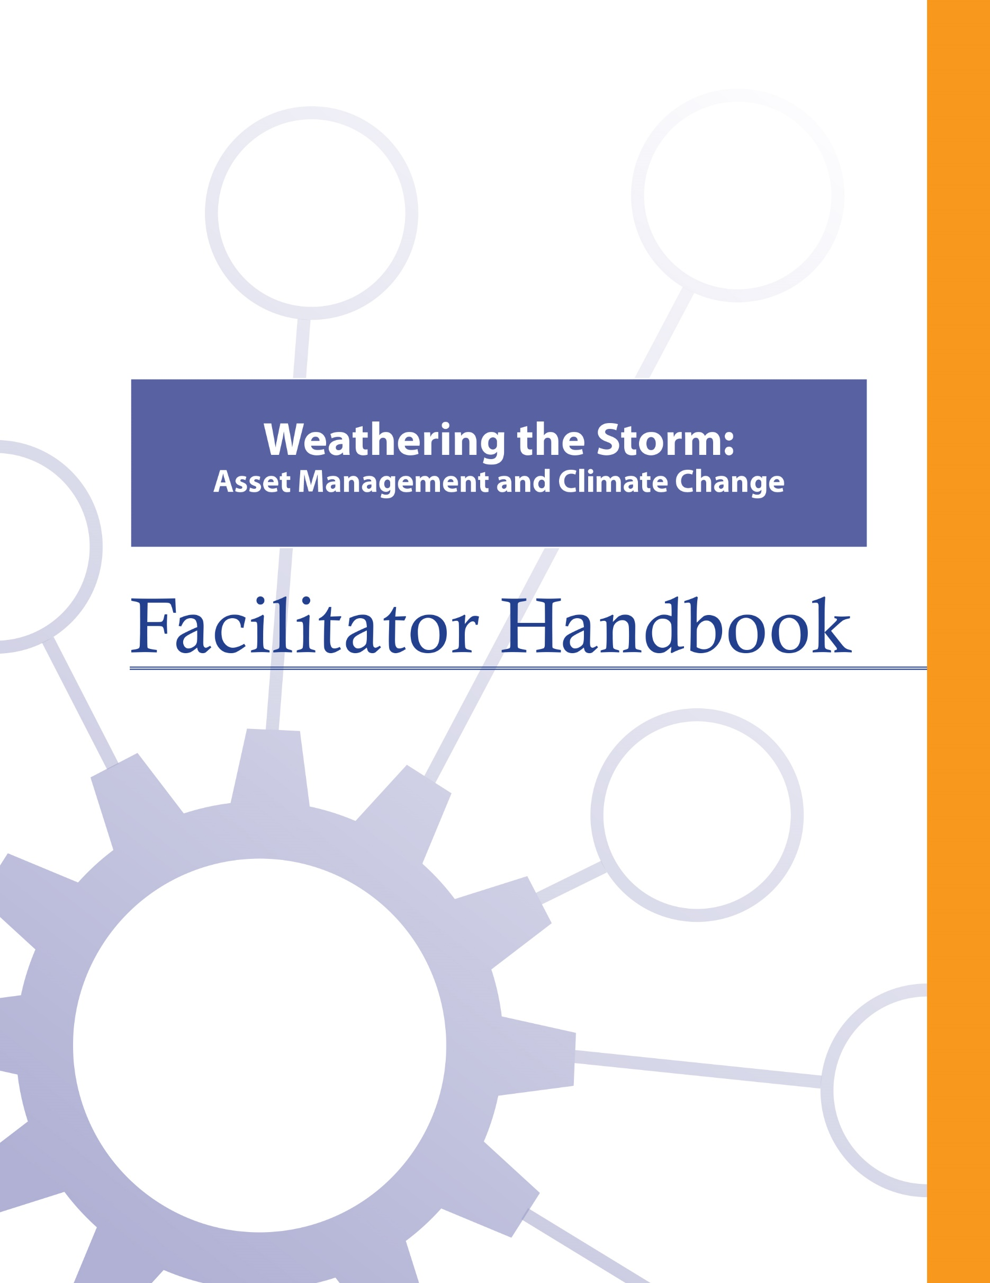

About the FCM
The Federation of Canadian Municipalities (FCM) has been the national voice of municipal government in Canada since 1901, advocating for the needs of municipalities and their citizens. FCM’s membership includes large cities, small urban and rural communities, and 20 provincial and territorial municipal organizations.

About RMA
Formerly known as AAMDC, Rural Municipalities of Alberta (RMA) is an independent association representing Alberta’s 69 counties and municipal districts. Since 1909, the RMA has helped rural municipalities achieve strong, effective local government.

About AUMA
Founded in 1905, the AUMA represents 269 urban municipalities including cities, towns, villages, summer villages, and specialized municipalities. AUMA works with federal and provincial governments and business and community stakeholders on a broad range of issues to strengthen the economic, social, cultural, and environmental vitality of its member municipalities.

This initiative is offered through the Municipal Asset Management Program, which is delivered by the Federation of Canadian Municipalities and funded by the Government of Canada.
fcm.ca/assetmanagementprogram

TABLE OF CONTENTS

How to Use this Facilitator Handbook 1
Characteristics of Adult Learners 2
Agenda 6
Facilitator Preparation 6
Introductory Remarks 7
Learning Goal: Asset Management Refresh 10
Module 1—Identify Infrastructure and Service Delivery Vulnerabilities 13
Learning Goal: Identify How Climate is Changing 13
Learning Goal: Identify Vulnerabilities in Infrastructure and Risks to Service Delivery 19
Module 2—Identify How to Use Asset Management to Prioritize and Manage Vulnerabilities 23
Learning Goal: Know the Basics of Asset Management and the Connection to Climate Change 23
Learning Goal: Identify How Asset Management is Used to Identify, Prioritize, and Manage Climate Change Risks and Vulnerabilities 25
Learning Goal: Identify How Asset Management is Used to Support Climate Change Mitigation 28
Learning Goal: Concluding Remarks 30

How to Use this Facilitator Handbook
This Facilitator Handbook was created to be a resource for the professionals who will be instructing the course on behalf of the AAMDC and AUMA. The Facilitator Handbook is intended to help instructors to provide consistency, and to facilitate the course effectively, within the instructional time available.

How to read the guide:
- The facilitator script and instructions are provided in the right column.
- Thumbnails of the slides corresponding to the script are in the left column.
- The facilitator’s script appears in normal type.
- Additional notes to facilitators appear in bold print.
- Sample responses, discussion points and answers for participant activities appear in italics.

Characteristics of Adult Learners
While we may act like it sometimes, adults are not just big kids. And, we don’t want to be taught like children. As adults, we learn in a very different way than our shorter, younger (maybe even thinner) selves. When we think about a typical learning environment, many of us recall past school days. During those times, our very identity revolved around being a student.
For most of us, the model we have for instructing comes from the teachers who taught us back in the day. However, the teaching techniques that worked for our grade eight English teacher may not be as appropriate for those of us now instructing adults – adults who are also our colleagues and peers. It is important for facilitators of adult education to understand how adults learn and to incorporate teaching principles and strategies that will meet the unique needs of adults and foster the most positive, engaging and productive learning environment possible for them.
What is so different about adults and how can we, as training professionals, incorporate instructional techniques that respect those differences? Below are some generally accepted insights that you may find helpful.

Adults want to have control over their learning
We adults tend to be self-directed. We have work, family and community responsibilities that require us to exercise some level of competence and control. In fact, we can get downright resentful when others take away our right to make choices around our own affairs. This is true when it comes to our learning experiences -- we typically need to exercise some control here, too. In fact, take away our sense of control over how and when we engage in formal learning and you will likely meet some resistance.

What’s a facilitator to do?
- Include adult learners in the planning of their learning (engage them in needs assessments and encourage their input on course objectives & content wherever possible).
- Encourage self-assessment and self-evaluation (rather than instructor-based evaluation).
- Establish a peer relationship with learners rather than the traditional hierarchical one.
- Make yourself available to adult learners outside of the formal learning environment if possible.

Adults, more so than youth, draw upon their experiences as a resource in learning
Been there, done that. Adults have a wealth of past experiences simply because we’ve lived longer than youth. As learners, our past experiences are important resources that we draw on. Adults tend to link new learning to prior learning (much of which is rooted in life experience). Learning is all about accepting and applying new ideas and concepts. For adults, that process often happens within the context of how the idea or concept “fits” with what we’ve already experienced.

What’s a facilitator to do?
- Take time to get to know the experiences of your adult learners and be intentional about helping them link new concepts and ideas with prior learning or experiences.
- Encourage open discussion on how new concepts and ideas being presented fit with the experience of learners.
- Encourage learners to share their experience for the purpose of teaching others. Ask versus tell. Using questions can draw out the information you want to focus on and is an effective way to encourage adult learners to apply their own skills and experience to facilitate their learning.

Adults tend to be more motivated in learning situations than youth
When adults find themselves in a formal learning environment, most times it’s because they want to be there. Adults are not typically motivated by gold stars or good report cards. Instead, they want a learning outcome that can be put to use immediately in concrete, practical and self-benefiting ways.

What’s a facilitator to do?
- Don’t spend a great deal of effort trying to motivate adult learners. Rather, see your role as facilitating the learning they are ready to experience.
- Ensure teaching is relevant to what learners want to learn and what they will be able to use back on the job.
- Accept that people will learn at different rates and in different ways. Some will learn by being told, others will learn by doing. Still others will need to be shown. Use a diversity of teaching methods to ensure your learners stay motivated to learn.

We’re generally more pragmatic in learning than youth
Adults are typically more interested in problem solving than information gathering. Learning “theory,” which must be stored away for future use, can be frustrating and seem irrelevant for many adult learners. Especially for adults, learning becomes complete when we put into practice what we are attempting to learn.

What’s a facilitator to do?
- Using job-related case studies and hands-on exercises and activities will help learners to immediately use what they’re learning in a problem-solving situation. The more often we use what we have learned, the better we can perform or understand it.

Some adults lack confidence in their learning
Some adults who have been away from a formal learning environment for some time may consider the learning “glory days” over. These perceptions can influence how confident they feel during learning situations. Interestingly, research shows that the attention span of the average adult is between 8 and 20 minutes.

What’s a facilitator to do?
- Provide opportunities for learners to receive constructive feedback on how they’re doing (either through guided self-evaluation, constructive input from other participants, or the facilitator’s own observations).
- Present information in a manner that permits mastery in “bite size chunks” with opportunity for hands-on application.

Many adults are more resistant to change than youth
Learning often involves change of some kind. Youth tend to be more idealistic and are often open to change just for the sake of change. However, over the course of being an adult, our experiences around change have not always been good and can lead us to be somewhat resistant to it.

What’s a facilitator to do?
- Encourage learners to explore the “why” of change, not just the “how.”
- Link new concepts to older, understood and accepted concepts.

A group of adult learners will typically be more diverse than a group of youths
A group of adults, more so than a group of youths, will vary a great deal in terms of age, experiences, and backgrounds. Differences can be a powerful resource for learning as adults collaborate together on tasks.

What’s a facilitator to do?
- Allow time for interaction between learners and create opportunities for them to work together in groups to collaborate and share perspectives and experiences.
- Present material in a variety of ways to accommodate a diversity of learning styles.

Agenda
Time | Topic | Facilitator’s Name
15 minutes | Introductory Remarks
30 minutes | - Asset Management Refresh
45 minutes | - Identify How Climate is Changing
30 minutes | - Identify Vulnerabilities in Infrastructure and Risks to Service Delivery
15 minutes | Refreshment Break
30 minutes | - Know the Basics of Asset Management and the Connection to Climate Change
45 minutes | - Identify How Asset Management is Used to Identify, Prioritize, and Manage Climate Change Risks and Vulnerabilities
20 minutes | - Identify How Asset Management is Used to Support Climate Change Mitigation
10 minutes | Concluding Remarks

Facilitator Preparation
- Scan recent local news articles for examples of climate change impact to service delivery. Be prepared to use these examples in the presentation.

Introductory Remarks

15 minutes |
Slides | Script
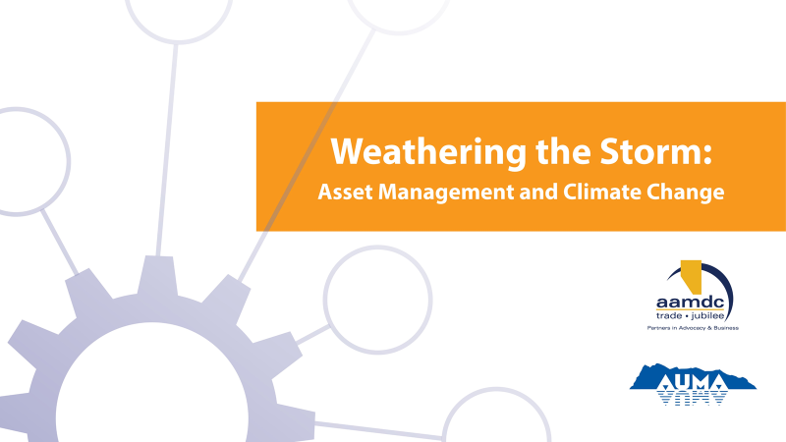
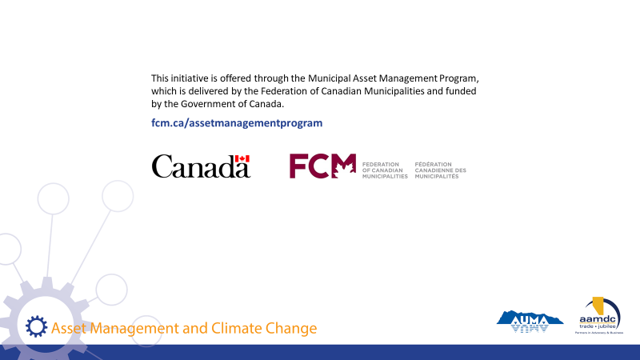
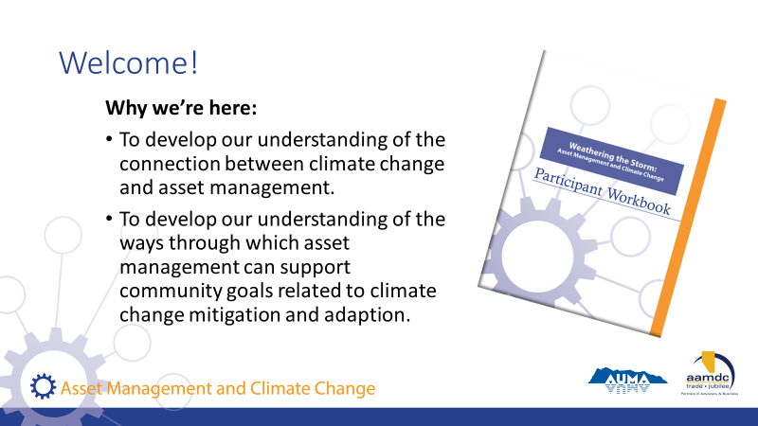 | State:  Welcome everyone! We are all here as part of the course titled “Weathering the Storm: Asset Management and Climate Change”. We’re here to:  Read slide
State:  - Before we get started, we also want to mention that there is funding out there to do asset management.  - So as you’re learning today, if you’re identifying things you’d like to bring back to your community, know that this grant program is available.  Read slide. | State:  - Before we get started, we also want to mention that there is funding out there to do asset management.  - So as you’re learning today, if you’re identifying things you’d like to bring back to your community, know that this grant program is available.  Read slide.
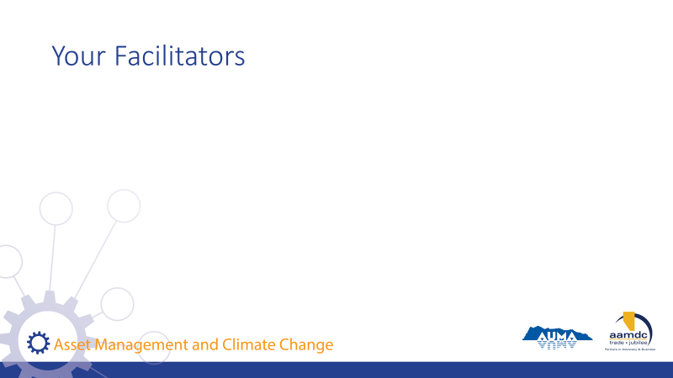 | Facilitator(s) introduce themselves.  Have participants introduce themselves.  Consider the use of icebreaker questions about where participants are at with asset management and climate change.
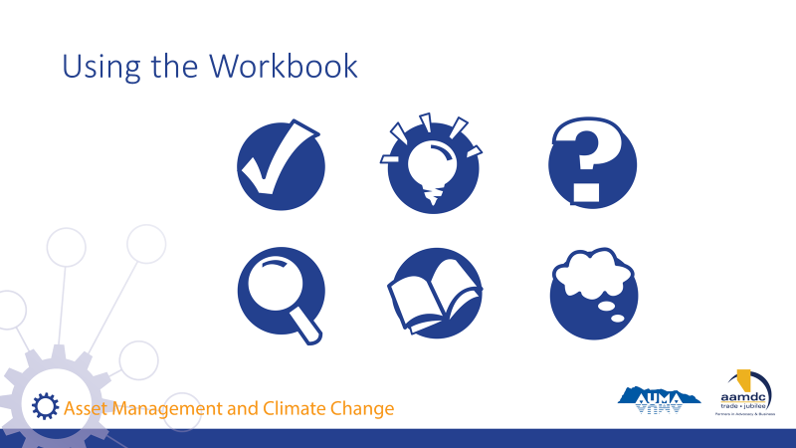 | Review how to use the learner workbook.  State:  Everything we will be covering in the course is contained in your participant workbook. However, we won’t necessarily be talking about all of the content in the workbook. I would encourage you, at some point, to read it over from start to finish.  We have also included a number of recurring icons intended to help you find relevant information in your workbook easily.  As icons appear (with click) on slide, review what each means and how to use it.  State:  The course is based on achieving specific learning goals. This icon identifies the learning goals, so you can be thinking about whether you are achieving them  This icon lets you know we’ve added an interesting fact or additional information related to the course material that we may not specifically cover in our discussion.  When you see this icon, it means we have included a reference to additional information on the topic that you can review at a later date.  Throughout the course, we will provide opportunities for you to apply your knowledge and share your expertise with a partner through various activities related to what you are learning.  In discussing municipal governance, there are a number of terms that may not be familiar to everyone. We’ve highlighted a few in these Glossary boxes and provided definitions. If you spot a term you aren’t familiar with and we haven’t provided a definition, please let us know by filling out the evaluation form and we will not only address it in this course but will add it to future participant workbooks.  Throughout the course, we want you to be continually thinking about how what you are learning in the course will apply to your role as elected official. For this reason, we’ve created space for you to reflect and record your thoughts on what the course content may mean in your world.
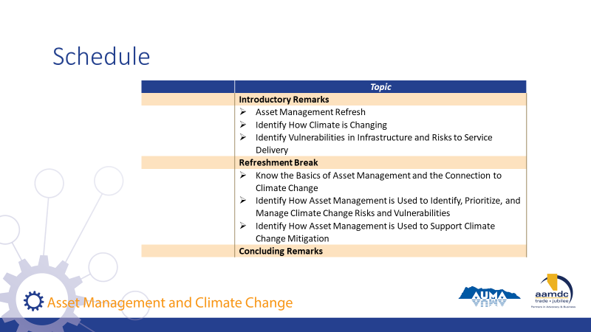 | Review course outline schedule on slide.  State:  As you can see, we will be covering a lot of content today.  Review schedule on slide.

Learning Goal: Asset Management Refresh

30 minutes |
Slides | Script
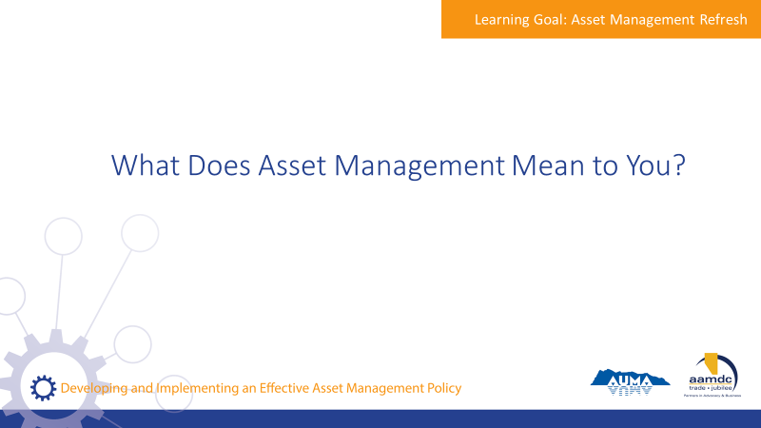 | State:  - This course is about how asset management relates to climate change.  - Before we get into the nitty gritty of climate change, we’re going to start with an overview of asset management.  - For some of you, this may be a refresher; for others, this will be new information.  Ask the group:  - Let me ask you, when you hear the term asset management, what comes to mind?  Encourage participants to share their thoughts with the large group.
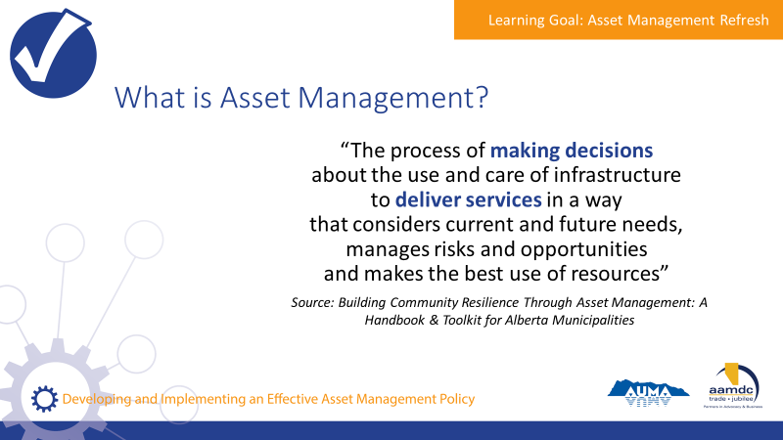 | State:  - Municipalities in Alberta are empowered to provide a range of services to their communities through provincial legislation, specifically the Municipal Government Act (MGA).  - A major component of service provision is taking care of the assets that make those services possible.  - An asset, also known as a tangible capital asset (TCA), is a physical component of a system that enables a service, or services, to be provided.  For example, pipes are the assets that deliver water service to homes, roads and traffic lights are the assets that make transportation possible, and recreation centres are assets that allow recreation services to be provided to the community.  - Municipalities have been managing assets for a long time. However, asset management is more than just managing assets or developing inventories of the assets a municipality owns.  - Here’s one definition of asset management that we think captures the essence of what it really is. We took this from the Alberta Handbook and Toolkit.  Review definition from slide.  State:  - They key terms here are “making decisions” and “deliver services”.  - Asset management is about using systems and processes to balance cost, risk, and LOS to make informed decisions that make sense for your community in the long run.  - Assets don’t exist for the sake of having assets, they exist to deliver services. Service delivery is the starting point for all asset management.
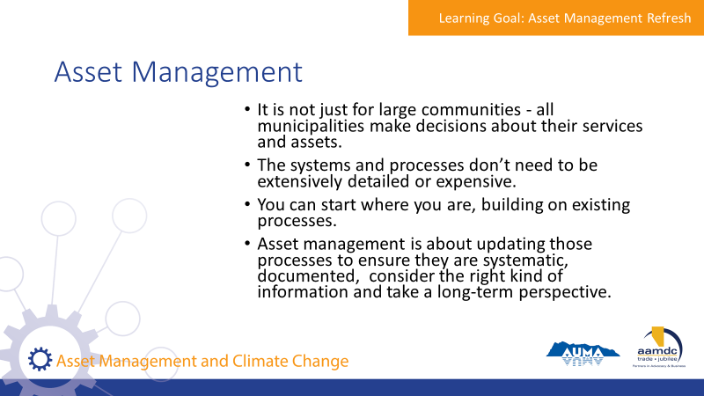 | State:  - It is not just for large communities. All municipalities make decisions about their services and assets.  - The systems and processes don’t need to be extensively detailed or expensive.  - You can start where you are. Your municipality probably already uses processes for things like planning and budgeting.  - Asset management is about updating those processes to ensure they are systematic, documented, consider the right kind of information and take a long-term perspective.
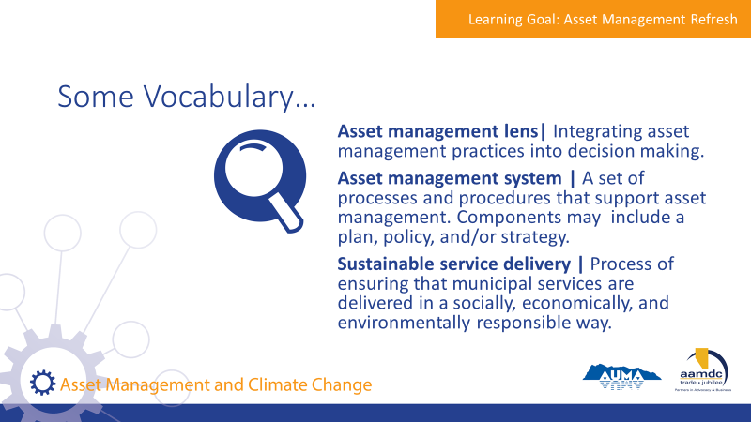 | State:  - There are a couple of terms we will be using as we discuss asset management, so we want to make sure we have a common understanding of them before we get into our discussion of asset management.  Review terms on slide.
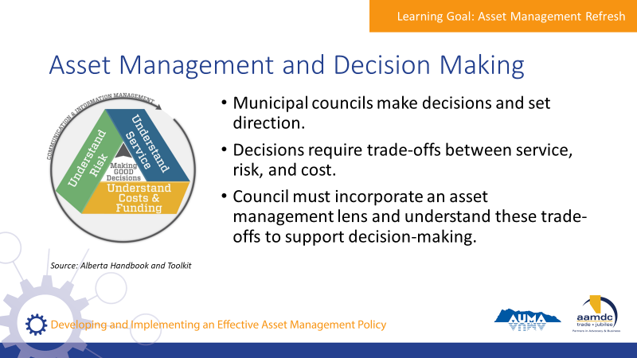 | State:  - Council’s role is to make decisions and set directions.  - Decisions require thinking about trade-offs between service, risk, and cost.  - Council should incorporate an asset management lens on decision making processes and request information from staff to understand these trade offs.
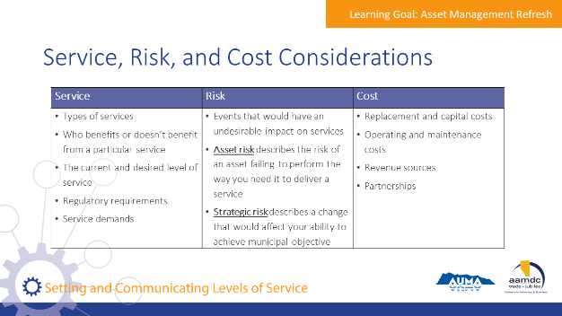 | State:  - This chart shows a summary of what should be considered for service, risk, and cost when evaluating trade-offs  Review considerations on slide.
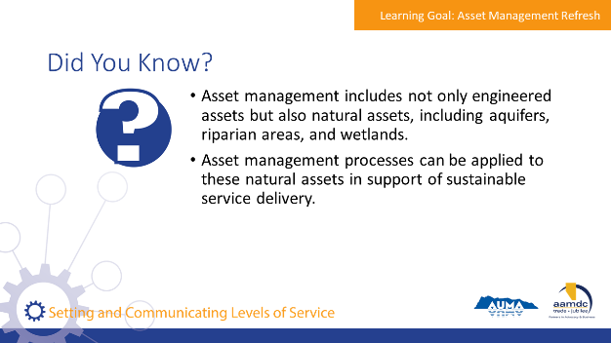 | State:  - Here are a few facts we thought you would find interesting.  Read facts on slide.  - Natural assets are critical to service delivery, and it’s useful to think through how these assets are cared for and invested in, in the same way that infrastructure assets are.  - The consideration of natural assets is particularly relevant when it comes to climate change mitigation and adaptation.  Ask the group:  - Does anyone know if their AM programs include consideration of natural assets?

Module 1—Identify Infrastructure and Service Delivery Vulnerabilities

Learning Goal: Identify How Climate is Changing

45 minutes |
Slides | Script
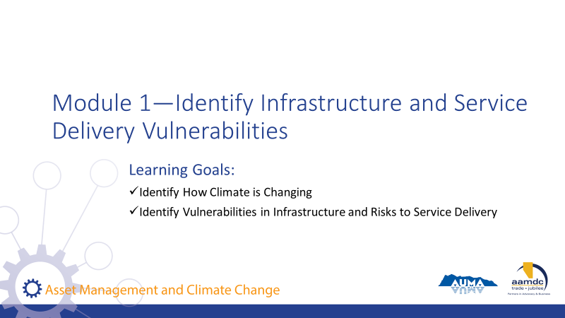 | State:  - This course has been designed with specific learning objectives for each module to state what learners should be able to do after completing a module.  - After Module 1, you should be able to:  - Identify how climate is changing  - Identify vulnerabilities in infrastructure and risks to service delivery  - If you don’t feel like you are mastering these learning objectives, or if you have questions about any of the content, we want to encourage you to let us know. Ask questions during the course at any time or see us during the break.  - Also, you will get out of the course what you put into it. So please participate fully and if there is anything that may get in the way of your full participation, we want to know that as well.
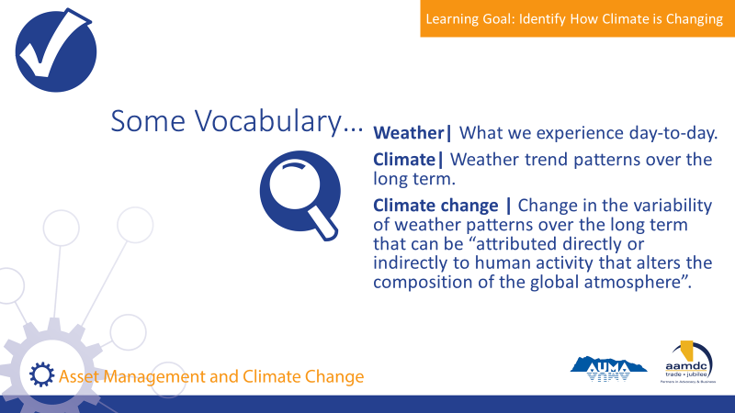 | State:  - Let’s start with some vocabulary. This will likely be familiar to many of you but we think it’s important that we’re all on the same page about the words we use.  Review terms on slide.  State:  - Human factors that are most directly attributed to climate change are increases in the concentration of greenhouse gases in the atmosphere, in particular carbon dioxide, methane, and nitrous oxide.  - Concentrations have been increasing from the industrial revolution to now through emissions from fossil fuels used in industry, transportation, and domestic energy use, as well as animal production and other agricultural activities.  - The climate also changes for reasons unrelated to human activity, but when you hear about climate change in the news, or in this course, this phrase is generally referring to human-influenced climate change.
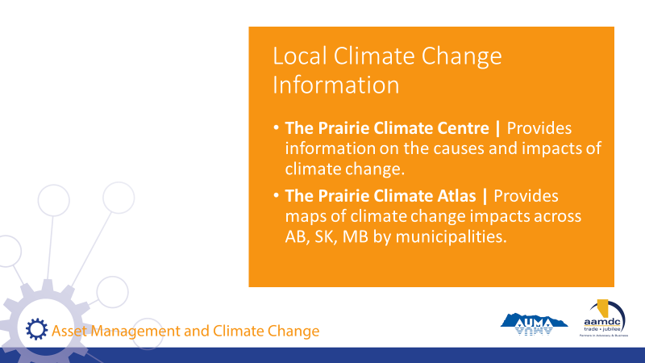 | State:  - Before we get started on discussing climate impacts in Alberta, we just want to highlight to great resources that we used to collect the information shown in the workbook.  - In addition to information provided by the Government of Alberta, you can also find climate information for your region from organizations shown on this slide.  Read slide.
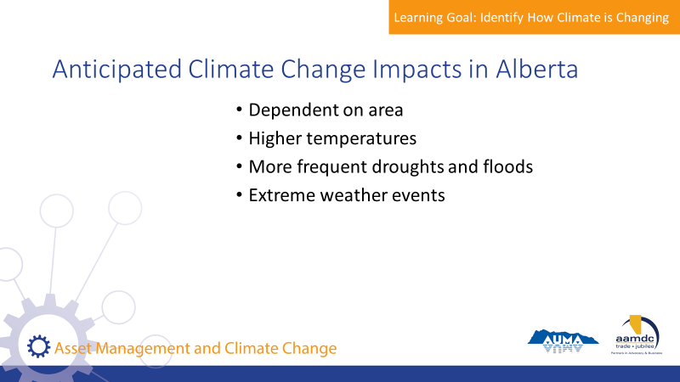 | State:  - The anticipated impacts of climate change in Alberta depend on the area, but some of the general impacts include:  - Higher temperatures  - More frequent droughts and floods  - Extreme weather events  - This information is provided by the Government of Alberta.
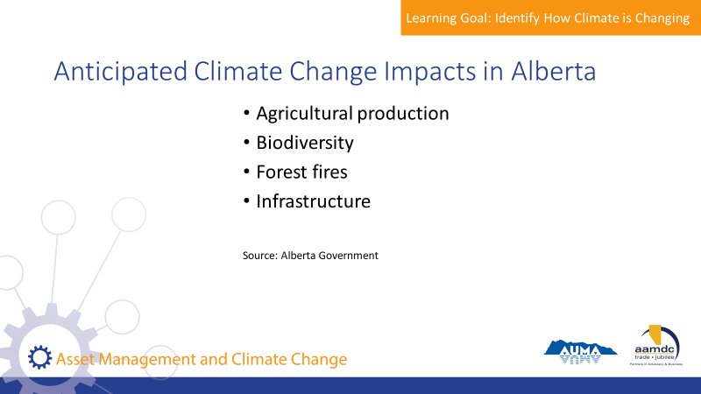 | State:  - These impacts may mean different things depending on the ecological system, industry, or community.  Go through each of the points on the slide.  Agricultural Production  - Agricultural production may see an increase or reduction to yields, depending on how temperature and rainfall changes affect crops.  - For example, some areas may seem their planting options expand with higher temperatures – it is anticipated the wine growing region of Ontario may expand north with rising temperatures and barley in Alberta could also benefit from rising temperatures.  - However, increased variability in temperatures and rainfall may make it harder for farmers in some areas to build sustainable farming practices.  - Changes in agricultural production may impact municipalities where agriculture is a significant industry.  Ecosystems  - Changing temperatures may impact biodiversity or change the geographical range of certain ecosystems.  - Your community likely already receives ecosystem services such as water, and these would be impacted by changes in rainfall patterns or increased drought.  Forest Fires  - Forest fires are linked to high temperatures and periods of drought or little rainfall.  Infrastructure  - Though average temperatures are expected to increase over the long term, one of the challenges of climate change is increased short-term variability and more extreme temperatures.  - Frequent periods of freeze-thaw cycles can be very hard on infrastructure. For example, this leads to more frequent and larger potholes in roads.  - Changes in temperature, precipitation, and the frequency of extreme weather events may also change the lifespan of your infrastructure.  - This is especially true if the events fall outside of the parameters the infrastructure was built for.  - Climate change has the potential to increase maintenance costs, or lead to more frequent replacement.
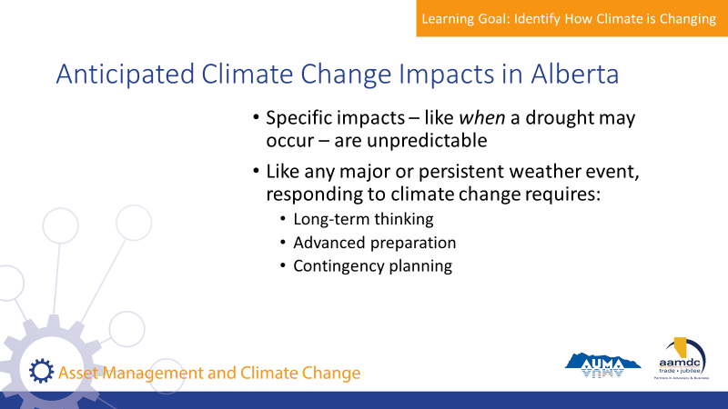 | State:  - Specific impacts, for example, when a drought may occur, are generally unpredictable in a way that can be easily planned for.  - Like any major or persistent weather event, responding to climate change will require:  - Long-term planning  - Advanced preparation  - Contingency planning
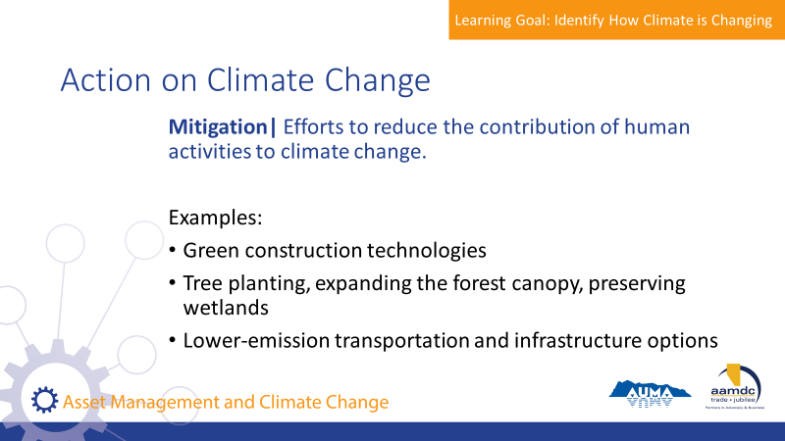 | State:  - In terms of responding to climate change, there are two main streams of action that we’ll discuss here.  - The first is mitigation, which means efforts to reduce the contribution of human activities to climate change, mostly through reductions in greenhouse gas emissions.  - A few of the ways that municipalities can contribute to mitigation are:  - Investing in green construction technologies for new buildings (e.g., LEED certification)  - Tree planting, expanding the forest canopy, and preserving wetlands – this increases carbon sequestration, which means the process of removing carbon dioxide from the atmosphere.  - Encouraging or “challenging” residents to walk to nearby destinations – to reduce car emissions AND support active living  - Increasing awareness of idling and putting up signs to discourage car idling  - Introducing and/or promoting the use of composting
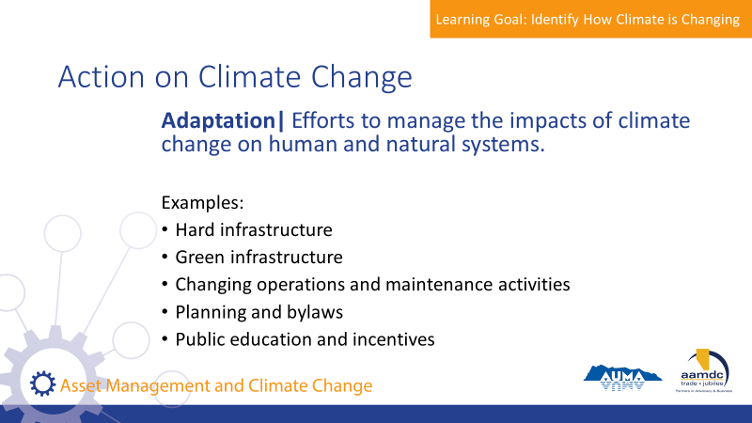 | State:  - The other stream of action is adaptation, which means efforts to manage the impacts of climate change on human and natural systems.  - Some of the ways that municipalities can contribute to adaptation include:  - Investing in hard infrastructure to deal with climate change impacts, such as increasing stormwater system capacity to deal with higher intensity rainfall and flooding  - Investing in green infrastructure, such as rehabilitating wetlands and other natural features to absorb more rainfall  - Changing operations and maintenance activities, such as increasing culvert cleaning to reduce blockages during high intensity rainfall events  - Using planning and bylaws to manage risky development, for example, preventing certain types of development in floodplains  - Using public education and incentives to modify behaviour, such as educating residents on using less water during drier months  - Adaptation is often very connected to assets, and therefore asset management.  - Because of this, it will be a major focus of the workshop today.  - Before we move on, it’s important to note that adaptation efforts may be necessary, but they are not always purely beneficial or benign to the environment.  - Especially when an immediate intervention is needed, adaptation may prioritize human settlement of natural environments.  - Many hard infrastructure projects contribute greenhouse gases or may interrupt natural processes.  - We’ll come back to this later, but this is something to think about when we think about the role of asset management in climate change adaptation.
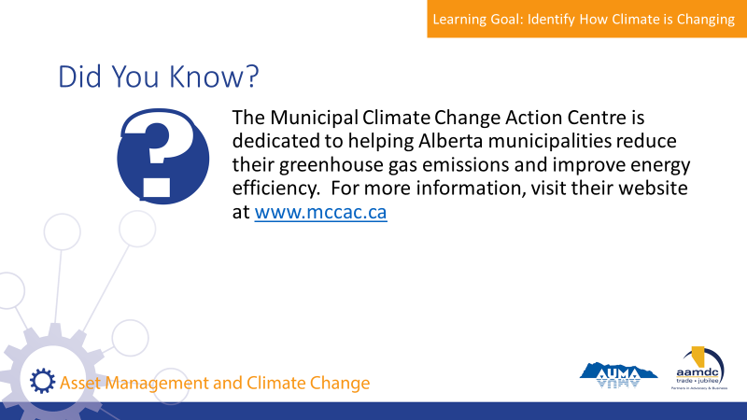 | State:  - If you want to know more about reducing greenhouse gas emissions, the Municipal Climate Change Action Centre is an organization dedicated to help Alberta municipalities do just that.
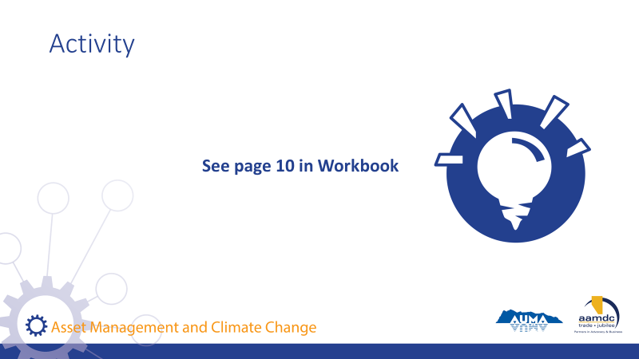 | Activity – page 10 (8 minutes)  State:  - In your table groups, review the questions on page 10.  Read questions.  When each table is done, as people to share some of their thoughts with the larger group.  Listen for each of the identified impacts from earlier slides.

Learning Goal: Identify Vulnerabilities in Infrastructure and Risks to Service Delivery

30 minutes |
Slides | Script
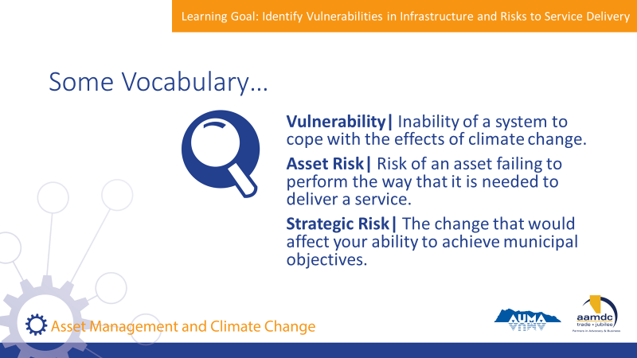 | State:  - As stewards of sustainable service delivery, council has an important role in understanding high-level risks to infrastructure and service delivery and providing direction to staff so these risks can be managed.  - These risks include climate change.  - Thinking about the ways that climate change will affect infrastructure and service delivery requires an understanding of a few key concepts: vulnerability and risk.  - Vulnerability is the inability of a system to cope with the effects of climate change.  - Risk describes the relationship between the likelihood and impact of an event that would interrupt a service. Risk can be broken down into asset risk and strategic risk.  - Asset risk is an event or occurrence of an asset failing to perform the way that is needed to deliver a service. E.g., pipe breaking, road reaching capacity, water treatment plant not meeting performance objectives.  - Strategic risk is an event or change that would affect your ability to achieve municipal objectives. E.g. insufficient asset renewal reserves, staff turnover, loss of knowledge.
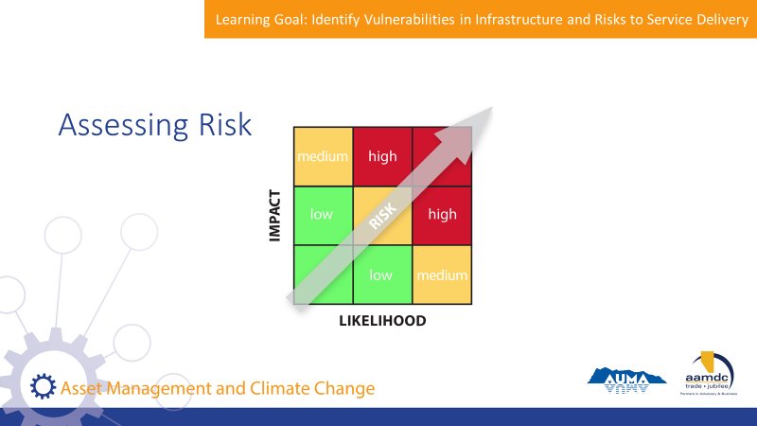 | State:  - Climate change is affecting our expectation about the impact and likelihood (or risk) of certain events.  - This is particularly relevant for natural disasters such as flooding and forest fires and how municipalizes can plan their infrastructure to cope with them.  - The image on the slide shows a simple way to consider risk. (Work through an example using the table).  - When assessing asset or strategic risks, climate change can impact both the likelihood and impact of certain events.
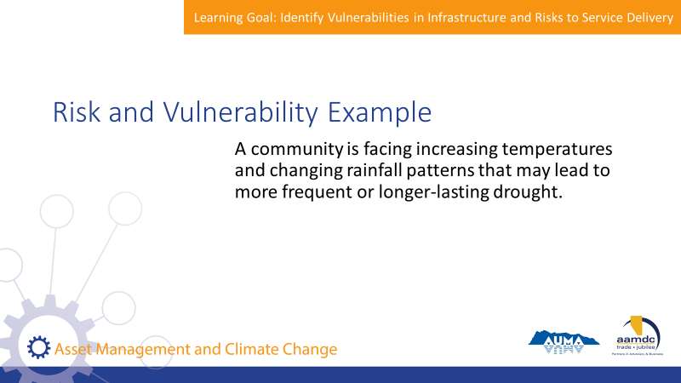 | State:  - Vulnerability and risk are related and can be easily confused so let’s go through an example.  Read example on slide.  - The water system, including the water source, was not designed to cope with drought conditions.  - The system is therefore vulnerable to the effects of drought.  - The risk depends on the likelihood of drought, and the consequence of drought. The consequence will be determined by factors such as the size of the population served by the water source, availability of alternate water sources, the size of the storage reservoir, etc.  - A system that is vulnerable may or may not present risks to service delivery.  - A topical example is the crisis currently facing Cape Town, South Africa. The city normally gets a lot of rain each winter that replenish its aquifers. However, for the past three years, the city has received significantly less rainfall than normal, which has put its entire system at risk. Cape Town could become the first major modern city to run out of water.
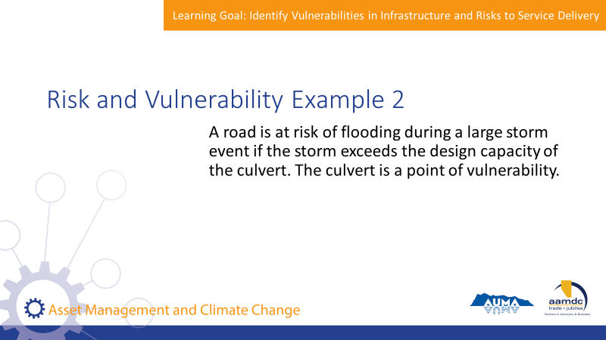 | State:  - A culvert was designed for storms of a certain size.  - If a storm exceeds that design standard, the culvert may become inundated.  - Therefore, the culvert is vulnerable to a large storm event.  - The road is at risk of being washed out if the culvert fails.
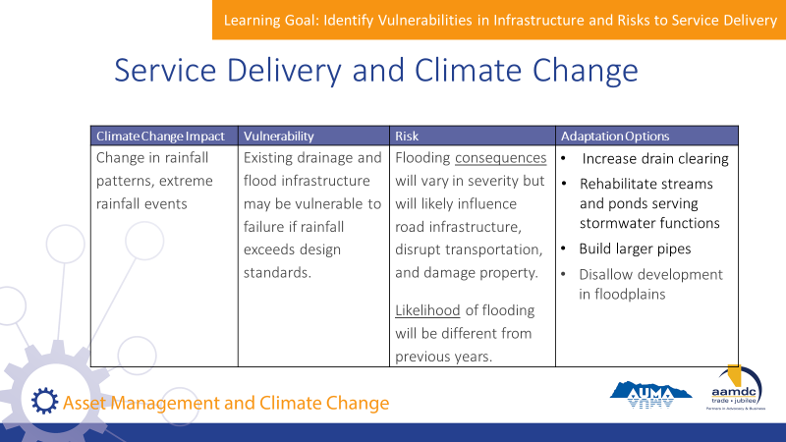 | State:  - Let’s delve into some of the ways that climate change is impacting infrastructure vulnerability and increasing risk to service delivery.  - This helps us to think through the connection between climate change and asset management. It’s important to distinguish between the vulnerability of the infrastructure, and the risk to service delivery because effective asset management is about focusing on the service delivery.  - There may be different ways of dealing with the vulnerability of the infrastructure so that the risk to service delivery is mitigated.  - Some solutions might be capital solutions, others might be operational solutions.  - Take a look at this example:  Review information on slide.  - You’ll notice in the last column, there’s a range of options to address the same vulnerability and risk.  Lead discussion with group.  State:  - Can you think of the strengths and challenges of each of the adaptation options?  - Do any of the options have the potential to contribute to greenhouse gas emissions or affect the natural environment negatively?  - How might a community evaluate and select from the various adaptation options?  - Pages 12 to 14 in your workbook provide a number of other examples. (consider working through these examples depending on the available time).
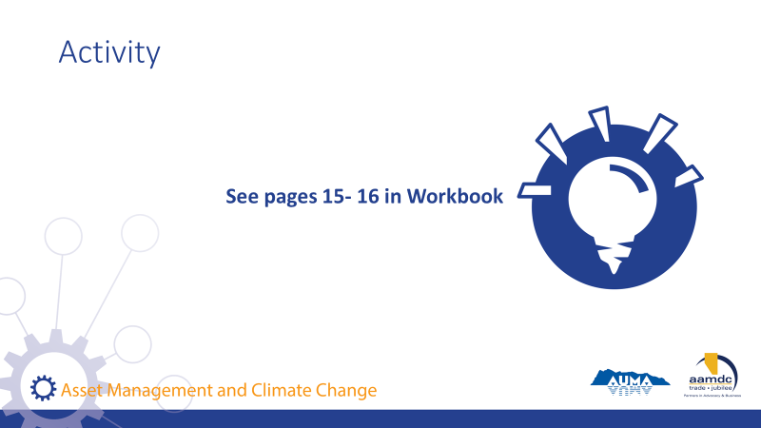 | Activity – pages 15 – 16 (15 minutes)  State:  - Let’s all turn to page 15 of your workbook.  - Consider this scenario.  Read scenario.  - In your table groups discuss the questions on this page.  - We’ll debrief together.  Debrief as a group. Ask each table to provide an possible answer to each question.  State:  - Now, let’s turn to page 16.  - What types of actions has your community taken to identify and respond to risks and vulnerabilities associated with climate change?  - Take a couple minutes and jot down your answers.  If there’s time, ask if anyone wants to share.

Break
15 minutes |

Module 2—Identify How to Use Asset Management to Prioritize and Manage Vulnerabilities

Learning Goal: Know the Basics of Asset Management and the Connection to Climate Change

30 minutes |
Slides | Script
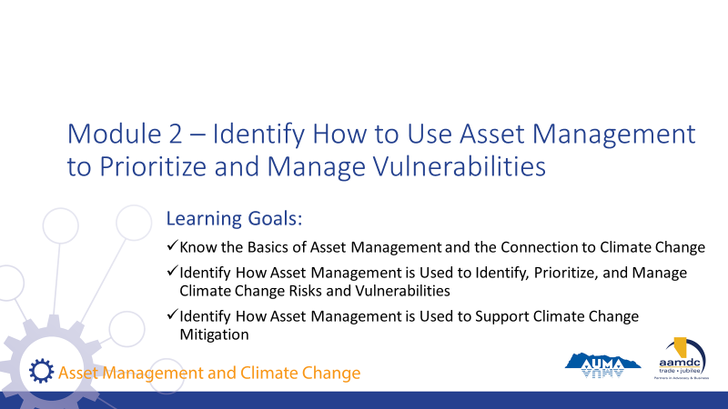 | State:  - Welcome back everyone.  - We’re moving on to Module 2.  Read module title and learning goals on slide.
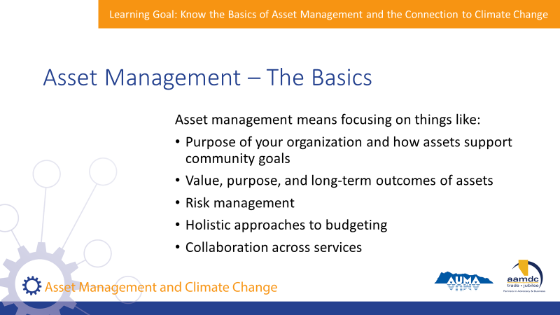 | State:  - Like we’ve mentioned, asset management is about sustainable service delivery.  - It means focusing on things like:  Read slide.
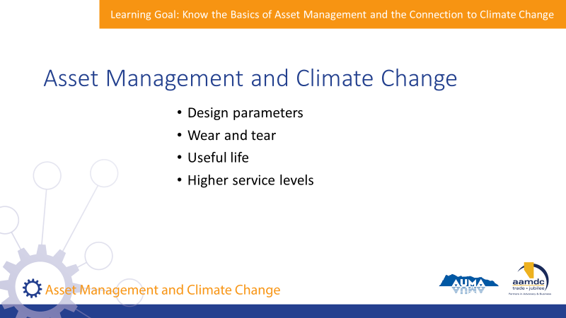 | State:  - Climate change can impact assets in numerous ways, some of which we’ve already discussed.  - The design parameters of some infrastructure may no longer be adequate if rainfall, temperature, or the frequency of extreme weather events changes.  - Certain climate change impacts may increase wear and tear on infrastructure, for example, increased temperatures may mean increased demand on cooling systems, leading to greater wear and tear.  - Or reduce the overall useful life.  - Or the municipality may need to make investments to be able to maintain current levels of service – for example, through providing greater stormwater system capacity to avoid increased flooding events.  - All of these impacts could lead to increased costs for the municipality, and/or increased risks to service delivery. However, these costs and risks can be effectively and efficiently managed when considered within asset management processes.
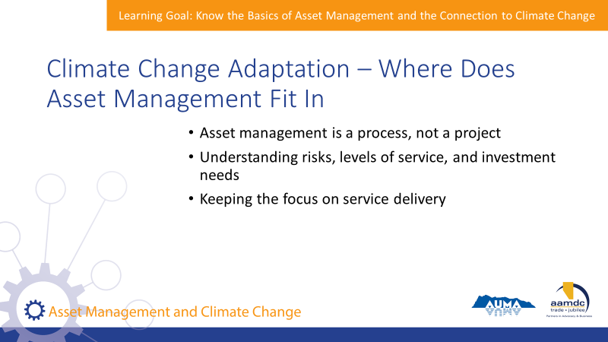 | State:  - For all of the reasons we’ve discussed, asset management is a key component for adapting to climate change because it describes the process of making decisions about your service delivery, and planning for the future.  - Asset management is a process, not a project – this lends itself well to coping with climate change because information is still emerging, and conditions may change. Asset management allows to assess and reassess the best way to manage your assets and make investments for the future.  - Thinking about climate change is key to understanding risks, levels of service, and investment needs. Addressing climate change separately from these core processes may lead to inefficient use of resources, duplication of effort, or unmanaged risks.  - Asset management keeps the focus on service delivery. This helps provide a framework for thinking about climate change adaptation, focused on what you can and should do, rather than how overwhelming global climate change can be. Remember, your community is adapting to changing conditions all the time!

Learning Goal: Identify How Asset Management is Used to Identify, Prioritize, and Manage Climate Change Risks and Vulnerabilities

45 minutes |
Slides | Script
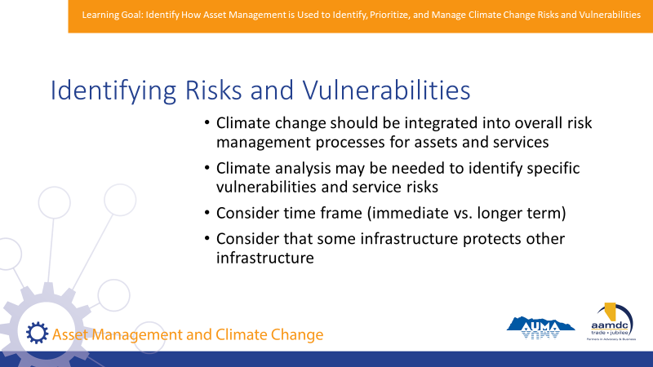 | State:  - Targeted climate analysis may be needed to understand risks and vulnerabilities.  - But, risks related to climate change are just one source of risks that a municipality may face. There are still many other risks to service delivery that need to be considered.  - All risks should be reviewed and prioritized together.  - Holistic approaches can help identify projects or responses that address multiple risks at once.  - For example – a culvert that is in poor condition may be replaced with one that is larger to handle increased water flows and debris if higher rainfall intensity is expected from climate change.  - Timeframe is important to risk management – some risks are more immediate, while others are expected to increase later on. Both the likelihood and consequence may change over time.  - Consider the protection that some assets offer to other assets.
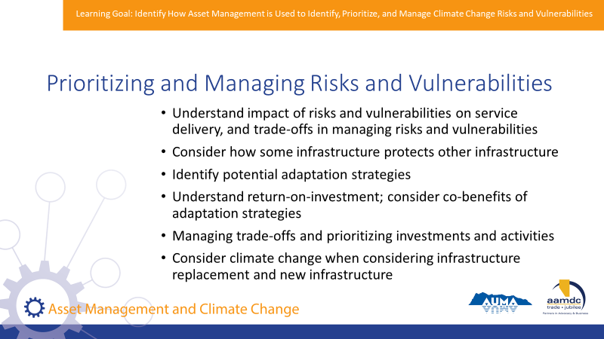 | State:  - Managing asset vulnerabilities is part of planning and investing in infrastructure, and therefore there are significant connections with asset management.  - It requires thinking about different factors that are part of asset management.  - For example:  Read considerations on slide.  - Asset management provides a way of thinking about investments in adaptive and resilient infrastructure when there is uncertainty about the timeline and scale of impacts.
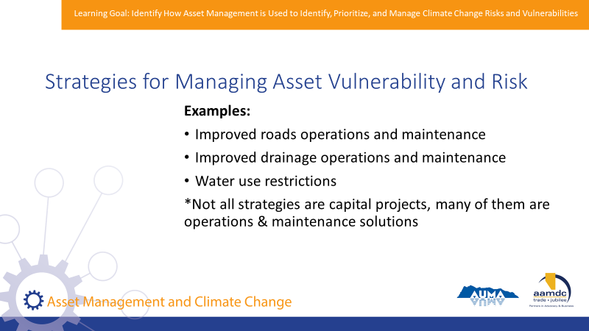 | State:  - Range of possible responses: do nothing, monitor, prevent/mitigate likelihood, prevent/mitigate consequences.  - The slide shows examples of the types of activities that can be used to address asset vulnerability and risk from climate change.  Read examples.  - You’ll notice that interventions do not need to be capital projects. It depends on the type of vulnerability and/or risk you need to address.
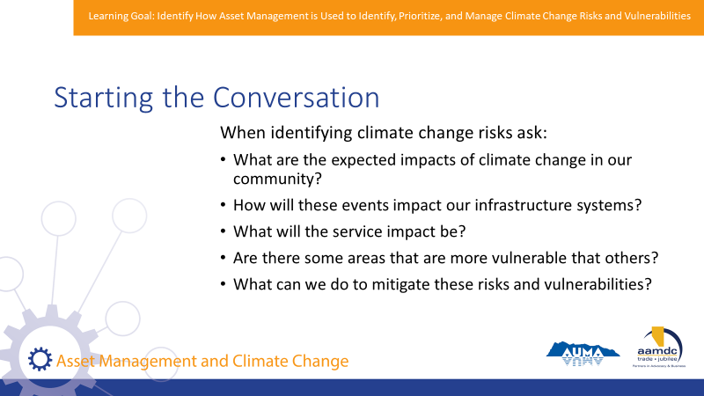 | State:  - If your municipality is just starting to identify climate change risks, you may not have access to detailed climate data and asset information. You can start the conversation with the right people in the room, including internal staff who have knowledge of infrastructure systems, the community, and finances. If your municipality has staff with knowledge on local climate change impacts, make sure to include them too.  - The initial conversation should cover questions like the following:  Read questions on slide.  - Having this conversation is not the role of council – it will be done by staff.  - However, council should understand key outcomes of this conversation and provide direction on what types of risks are acceptable to the municipality and what types are not.  - In some communities, council can encourage or request staff to have these conversations and report back to council.
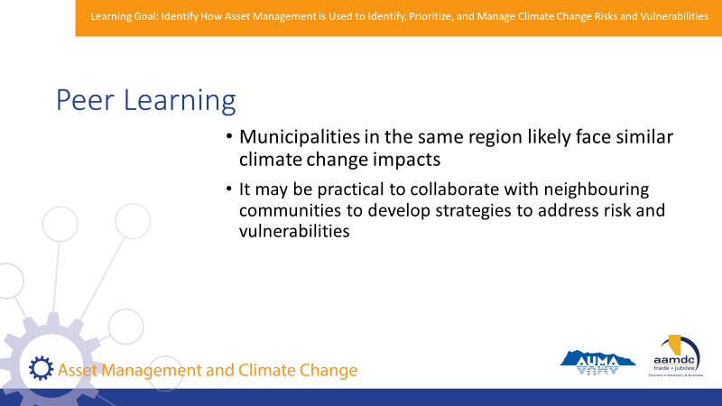 | State:  - When considering how your community can respond to climate change, you don’t necessarily need to go it alone.  - Municipalities in the same region will likely face similar climate change impacts.  - There may be opportunities to collaborate with your neighbours to study local impacts of climate change or develop strategies to address risk and vulnerabilities.
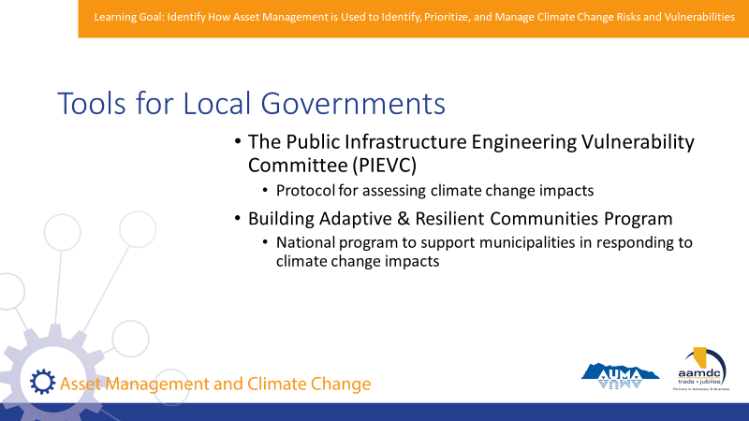 | State:  - There are some tools and processes available to help local governments in Canada address risks and vulnerabilities related to climate change.  - The ones on the slide are two examples:  Read slide.  - You can find links for these tools in the resources section of your workbook.
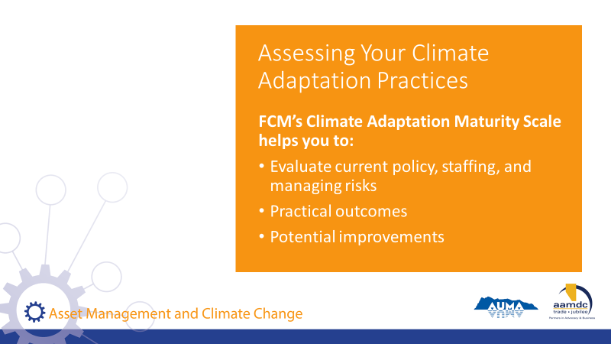 | State:  - If you’re just getting started, or want to better understand where your community is with climate change adaptation, check out FCM’s Climate Adaptation Maturity Scale.  - The scale will help you (from their website):  - Evaluate how your community incorporates climate adaptation into policy, staffing, and managing risks within projects and teams.  - Identify practical outcomes with your municipality’s current climate change adaptation practices.  - Quickly identify areas for potential improvement in current practices.  - Advance at a pace that suits your community.
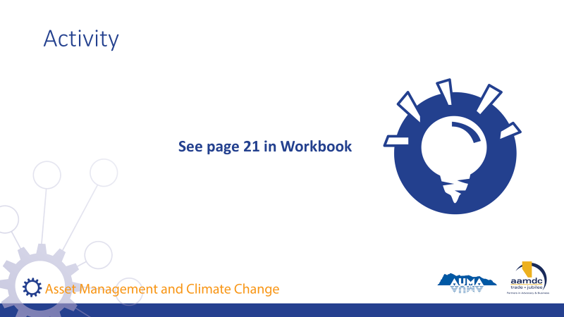 | Activity – page 21 (15 minutes)  - Let’s all turn to page 21 in your workbook.  - In your table groups, consider some of the climate change impacts we discussed earlier. Some examples are listed on page 21.  - How might these adaptation actions align with other asset management activities or other infrastructure risks?  - How would you prioritize competing risks?  - Think through those questions in your groups and we’ll debrief together.  Debrief - Ask each table to provide an example for both questions.

Learning Goal: Identify How Asset Management is Used to Support Climate Change Mitigation

20 minutes |
Slides | Script
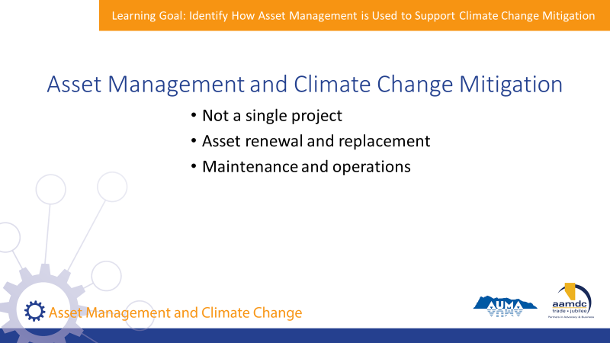 | State:  - Climate change mitigation is about taking action to reduce your community’s greenhouse gas emissions.  - When you consider which assets to renew or replace, it’s a good time to revisit how services are delivered and identify if there are opportunities to deliver those services in a way that produces fewer GHGs.  - Incorporating climate change mitigation doesn’t have to be a single, major action.  - In fact, it can be more meaningful to think about mitigation during regular processes.  - Asset management provides an opportunity to do this because it’s not a single project – it is the ongoing process of managing your assets and planning for the future.  - It provides an opportunity to think about improvements and community goals through asset renewal and replacement, as well as maintenance and operations.
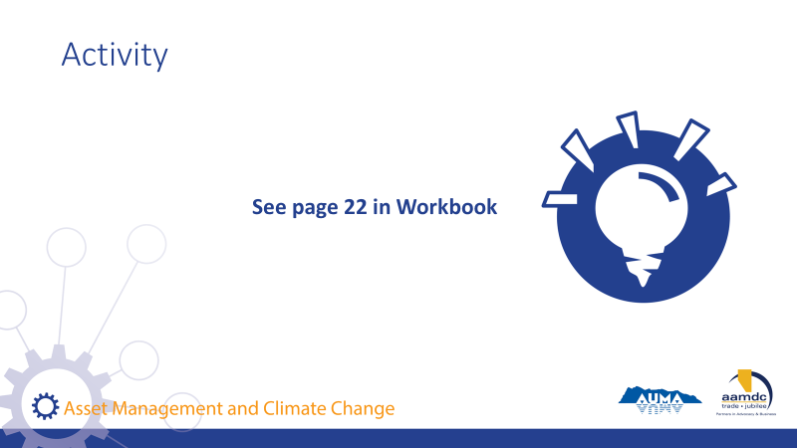 | Activity – page 22 (10 minutes)  State:  - With the last activity of the day, let’s think about how mitigation can be considered during asset renewal or replacement.  - Turn to page 22 in your workbooks.  - With your table group, consider the two scenarios presented.  - Are there opportunities to use less energy and reduce GHGs in the asset renewal or replacement process in each scenario?  - Discuss and we’ll debrief as a group.  Debrief – Ask each table group to share one example.
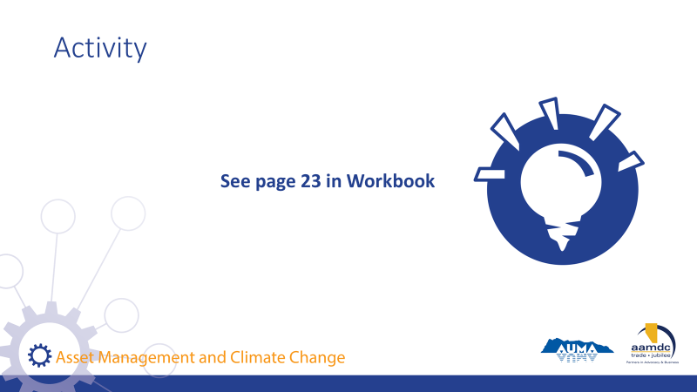 | Activity – page 23 (5-8 minutes)  State:  - Turn to page 23 in your workbooks.  - Asset management is a process, and climate change responses should be integrated throughout.  - What opportunities exist through the process of asset management to integrate climate change responses?  - Think through the whole AM process and AM activities, not just asset replacement  - Consider the changes in AM Policy  - Financial planning, including debt and reserve management  - Risk assessments – incorporate climate change  - Levels of service – look at how LOS is changing and what is sustainable to deliver. E.g. can you keep re-building in a flood plain?  - Update design standards for new /renewed infrastructure  - Ensure staff are trained in how to identify climate change vulnerabilities, service delivery risks, and mitigation measures  - Coordinate infrastructure projects for co-benefits: CC adaptation, mitigation, managing other risks, etc.

Learning Goal: Concluding Remarks

10 minutes |
Slides | Script
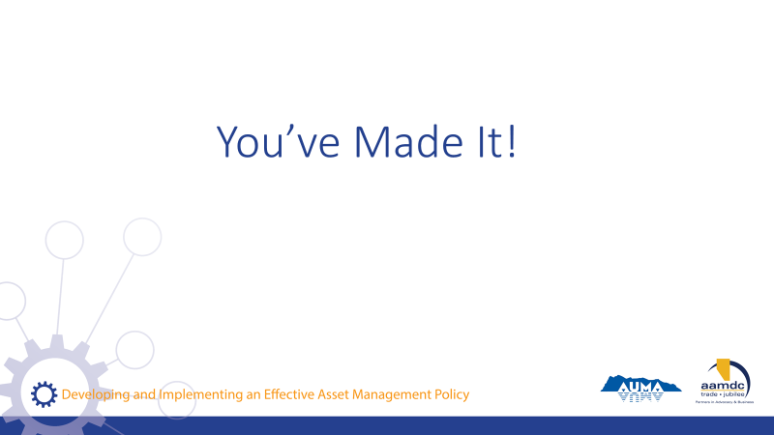 | State:  - Well, you’ve made it!  - Here we are at the end of the course.  - I hope you found today full of learning, good conversation, and shared insight. I want to thank you for joining us.  - Remember, today is just a start.  - Together, we’ve laid the foundation, but we hope that you’ll continue to learn, ask questions, and participate in other opportunities to expand your knowledge of risk and asset management.  - Throughout the workbook, and at the back, you can find the glossary and a list of resources if you ever need to reference something you learned in this course.
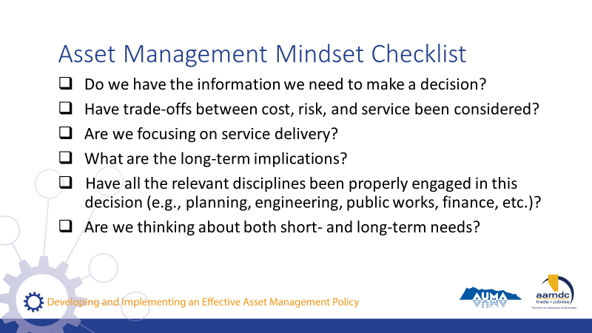 | State:  - If you got anything out of today, we hope that it was an understanding of how an asset management mindset can support you in your role as an elected official and steward of community well-being.  - If you’re ever stuck, start by asking yourself some questions:  Read questions on slide.  State:  All of these questions apply to the integration of climate change and asset management.
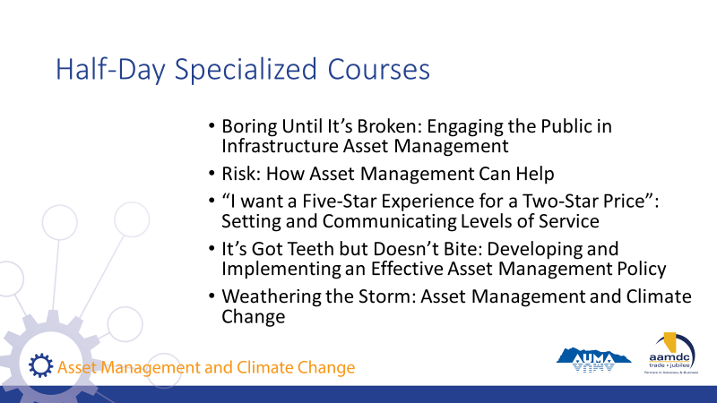 | State:  - AUMA and RMA offer five half-day courses as part of these series on specific topics related to asset management.  Read courses on slide.  State:  - If you want to find out more, talk to us after class.
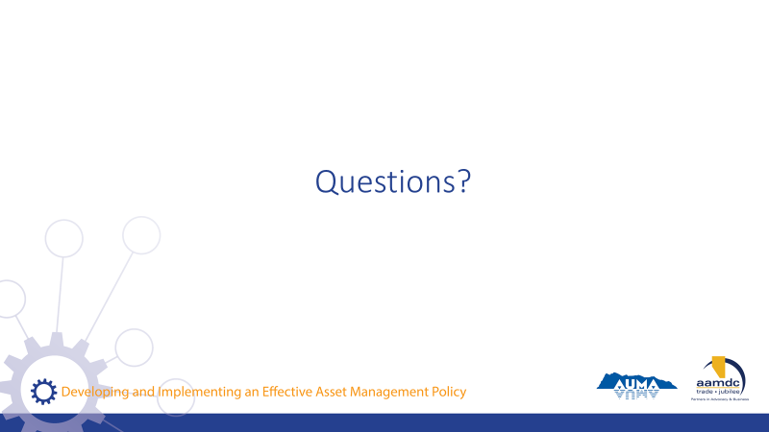 | State:  - Before we leave for the day, does anyone have any remaining questions about anything we covered?
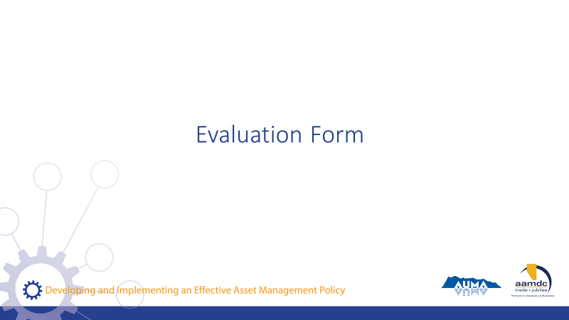 | State:  - Before you leave today, we would really value getting your input on this course.  - Your input will help us to understand how the course helped you (what worked for you) and where we can be making improvements.  - Thanks for taking about 10 minutes to provide your feedback. Once completed, you can leave your forms on (pick a central location for all forms so they remain anonymous).

NOTES

